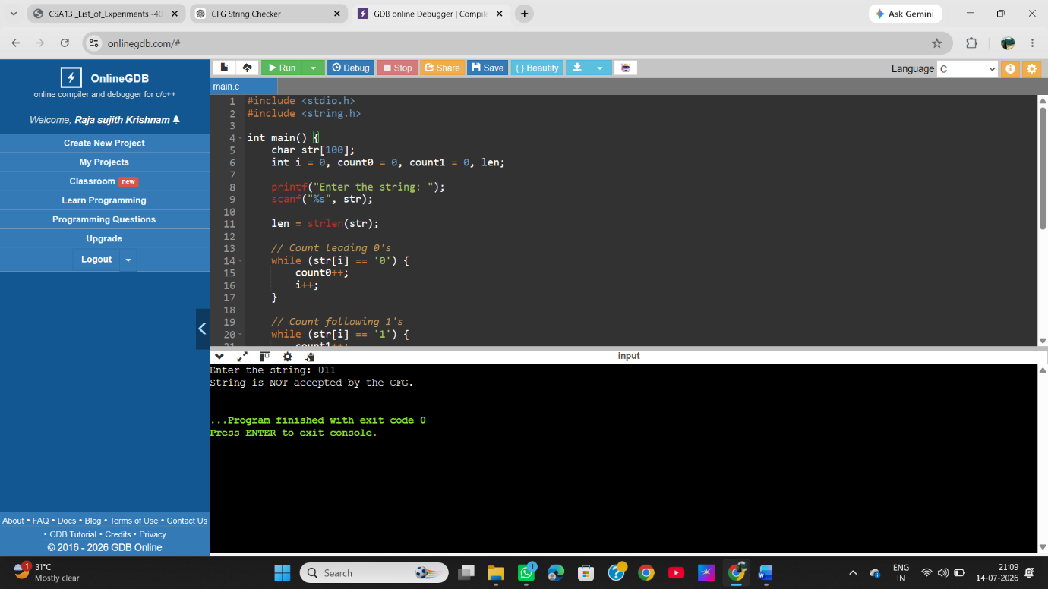
EXP 6 : Write a C program to check whether a given string belongs to the language defined by a Context Free Grammar (CFG) S → 0S1 | ε

